**POC 1: R&D of trellis feature of Spotfire in Power BI.**

Possible Solutions:

* Achieve through any existing visual
* Import Visual from marketplace
* Create visual using R Script

1. Achieve through any existing visual:

With this, the result is partially achieved but still not meeting the requirement. The output is shown below.

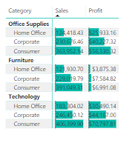

Pros: This is achieved with the help of “Table Visual” which in which the ‘Data Bars’ are turned on in the conditional formatting section.

Cons: Visual can’t be presented in vertically

1. Import Visual from marketplace

The result can be achieved from a visual from marketplace called “Stacked Column Chart by Akvelon”. The output is shown below.

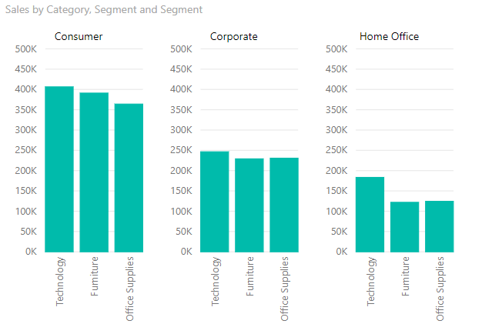

Pros: Best possible solution, which gives tooltips and other features of the visual.

Cons: Three y-axis are visible, a common y-axis can’t be achieved.

1. Create visual using R Script

A script is written in R language which uses three libraries ‘ggplot2’, ‘ggthemes’ and ‘scales’ to create the trellis visual and the output is shown below (as a reference).

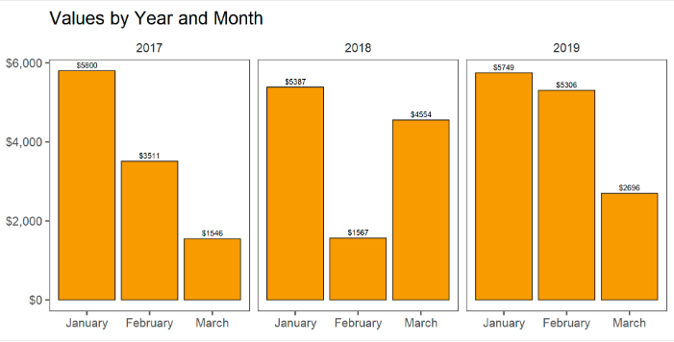

Pros: A common y-axis can be achieved using this R script.

Cons:

* No tooltip will be available in the visual.
* R environment and all three libraries should be installed in every machine where the visual is used.
* Will not adapt to new data, let’s say we add a new column in table, but till we do not update our script code, the visual will not change
* Will not work with in-built Slicer visual and drilldown functionality is not available.

Important Links for reference:

* [Create Trellis Bar Charts in Power BI](http://datalore.tech/blog/2019/4/2/create-trellis-lattice-charts-in-power-bi-using-r)
* [Creating Power BI visual using R](https://docs.microsoft.com/en-us/power-bi/desktop-r-visuals)
* [Using an external R IDE with Power BI](https://docs.microsoft.com/en-us/power-bi/desktop-r-ide)